

AGENDA
August 14th, 2014
Socorro City Hall Chambers
111 School of Mines, Socorro, NM 87801
12:00 pm-1:00pm

Call to Order 12:05

- Introductions/ Work Agreements 12-05-12:10

- Approval of Agenda 12:12
- Approval of Minutes 12:14
- Capacity & Readiness Workgroup 12:16
  - Leadership
  - Community Climate
  - Knowledge about the issue
  - Resources for Prevention Efforts
(Time, money, people, space, ect.) 12:18-12:50
- Goals-Mission-Vision
*We will be working on one of these a meeting till 12:50
Done**** Voting on one

- Adjournment 1pm
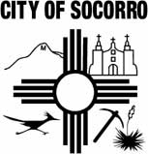

Next Meeting: September 11th, 2013, 12pm-1pm,
City Hall Chambers
Meetings are the 2nd Thursday of the Month

