

AGENDA
July 9th, 2014
Socorro City Hall Chambers
111 School of Mines, Socorro, NM 87801
12:00 pm-1:00pm

Call to Order 12:05

- Introductions/ Work Agreements 12-05-12:10

- Approval of Agenda 12:12
- Approval of Minutes 12:14
- Capacity & Readiness Workgroup 12:16
  - Community Awareness of Prevention Efforts 12:18-12:50
- Goals-Mission-Vision
*We will be working on one of these a meeting till 12:50
Done**** Voting on one
- Adjournment 1pm

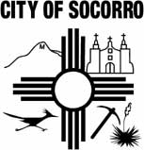

Next Meeting: August 14th, 2013, 1pm-2pm,
City Hall Chambers
Meetings are the 2nd Thursday of the Month

