

AGENDA
June 12th, 2014
Socorro City Hall Chambers
111 School of Mines, Socorro, NM 87801
12:00 pm-1:00pm

Call to Order 12:05

- Introductions 12-05-12:15

- Work Agreements 12:15-12:20
- Approval of Agenda 12:20
- Sign MOU’s 12:25-12:30
- Take Readiness Assessment 12:30-12:35
- Mission-Vision
*We will be working on one of these a meeting till 12:35-12:45
Done
- Capacity & Readiness Workgroup
  - Community Awareness of Prevention Efforts 12:45-12:59
- Adjournment 1pm

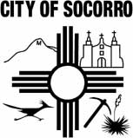

Next Meeting: TBA
City Hall Chambers

